Bushfire

Factors

Temperature

Temperature is the main factor, especially in Summer and Autumn.

Wind

Humidity

Relative humidity is commonly used to measure atmospheric moisture.

Pressure

Adding a feature like a trough or front that changes the wind direction increases the danger.

Actions

LOW

Prepare your emergency kit.

MED

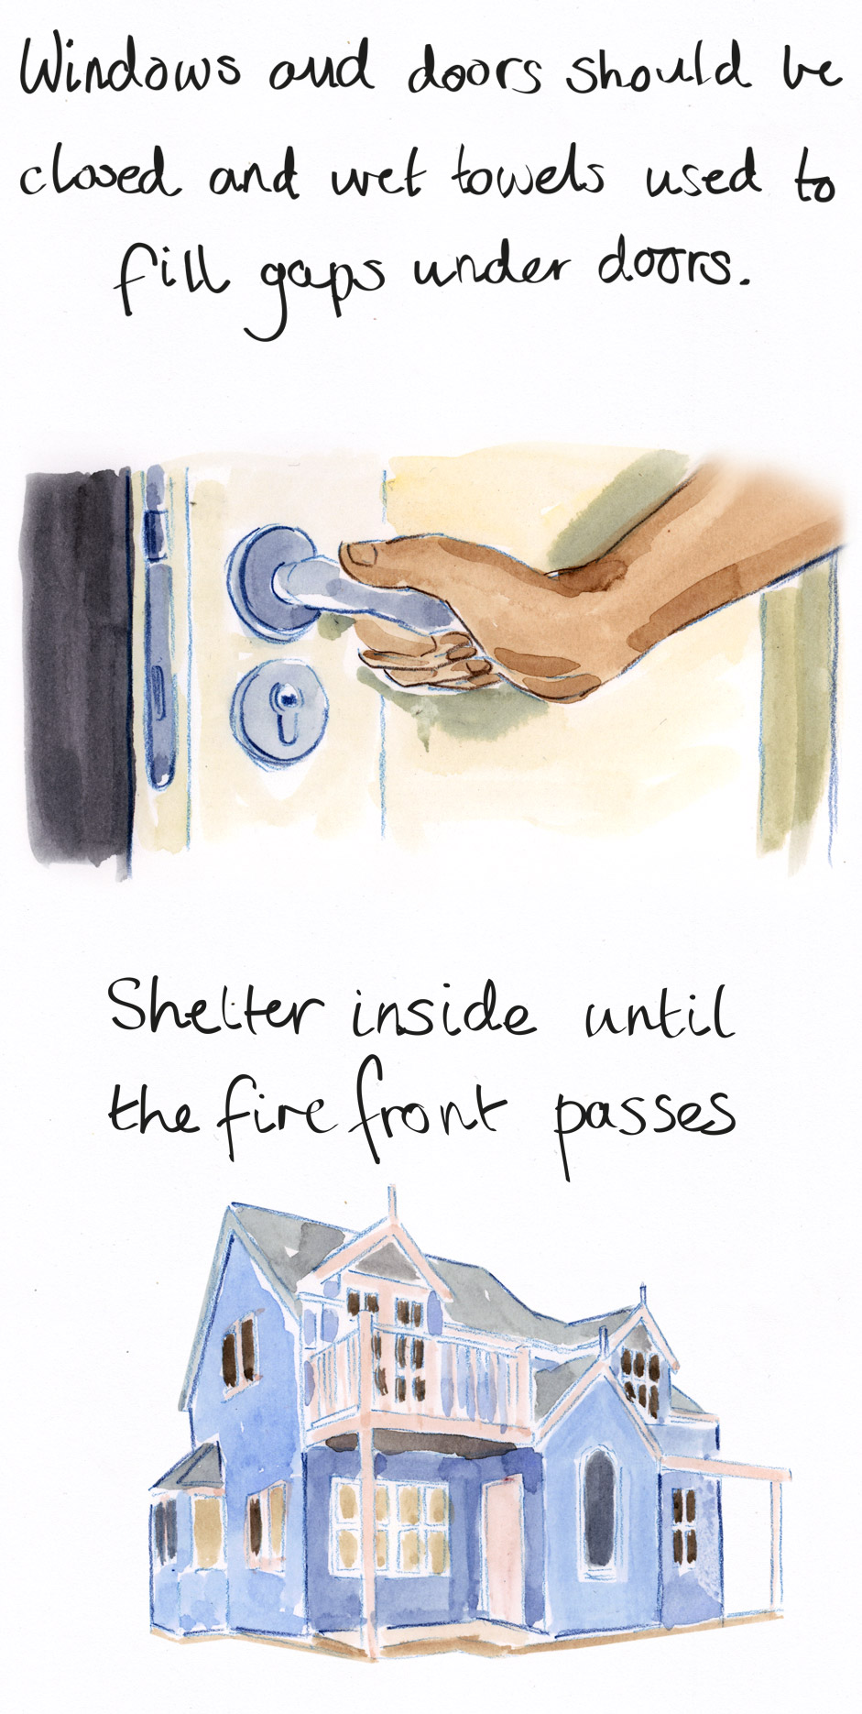

HIGH

Flood

Factors

Rainfall

Air pressure

Water Level

Humidity

Actions